***Exercise 2***

1. Create two users, user1, user2,

adduser user1

adduser user2

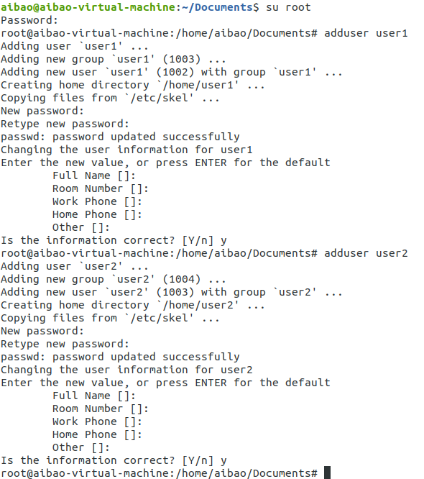

1. create one group dcadmin

groupadd dcadmin

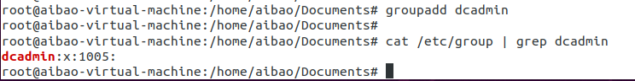

1. Add user1 in a primary group dcadmin

usermod –g dcadmin user1

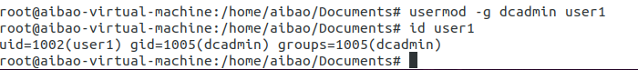

1. Add user2 in primary group user1

usermod –g user1 user2

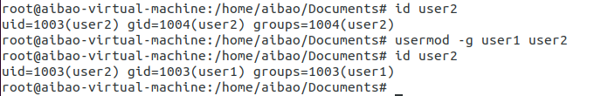

1. create a file (filem) from user1, who is the owner user and the owner group

touch filem

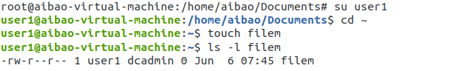

1. Delete user2, check is the user still exist or the primary group still exist

userdel user2

cat /etc/group | grep user2

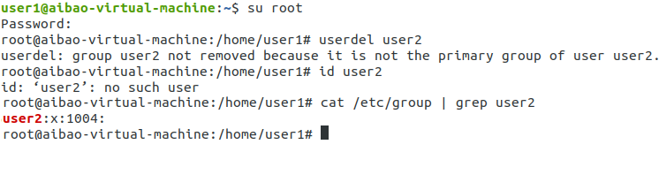

1. From the root user, create file11. Change the permission using the symbolic method to be

User🡺 read write and execute

Group 🡺 read and write

Other🡺 nothing

touch file11

chmod u=rwx,g=rw,o= file11

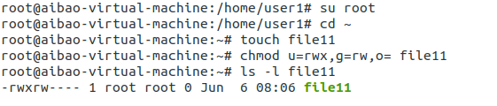

1. Change the permission using the numerical method to be

User🡺 read and execute

Group 🡺 read and write and execute

Other🡺 read and write

chmod 576 file11

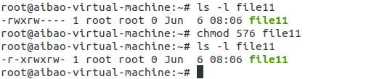

1. From the root user, folder11 and create file12 inside. Change the permission of only the folder using the symbolic method to be

User🡺 write and execute

Group 🡺 read

Other🡺 read and write

mkdir folder11

touch folder11/file12

chmod u=wx,g=r,o=rw folder11

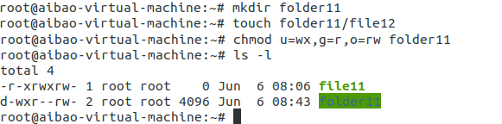

1. Change the permission of the folder and the file inside using the numerical method to be

User🡺 read, write and execute

Group 🡺 read and execute

Other🡺 nothing

chmod 750 folder11

chmod 750 folder11/file12

